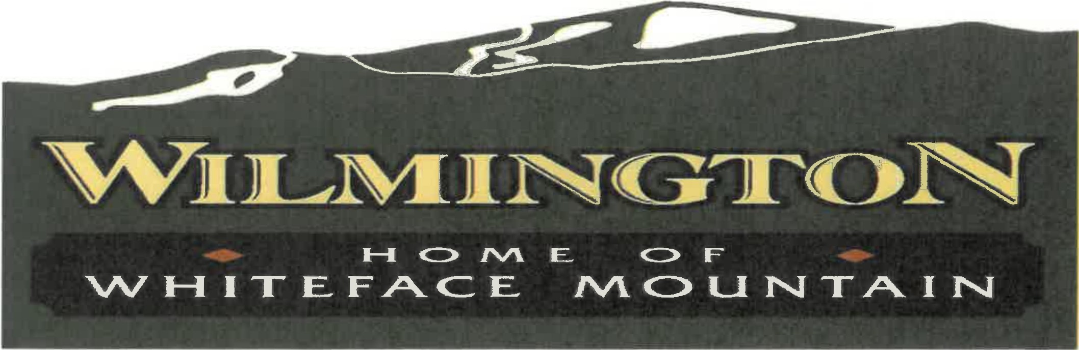

***This is to let everyone know*** that a quorum of the WILMINGTON TOWN BOARD will be meeting in person on May 14, 2025 at 4:00 PM.

***Location:*** The former Coarding property on NYS Route 86, Wilmington (opposite the Wilderness Inn).

***Purpose:*** Onsite inspection of the proposed affordable housing project with members of the project manager, Adirondack Roots. The public are invited to visit as well.

This is only an informational meeting, and there are no motions, resolutions, or actions on any agenda.

Dated: May 7, 2025

Favor J. Smith, Supervisor