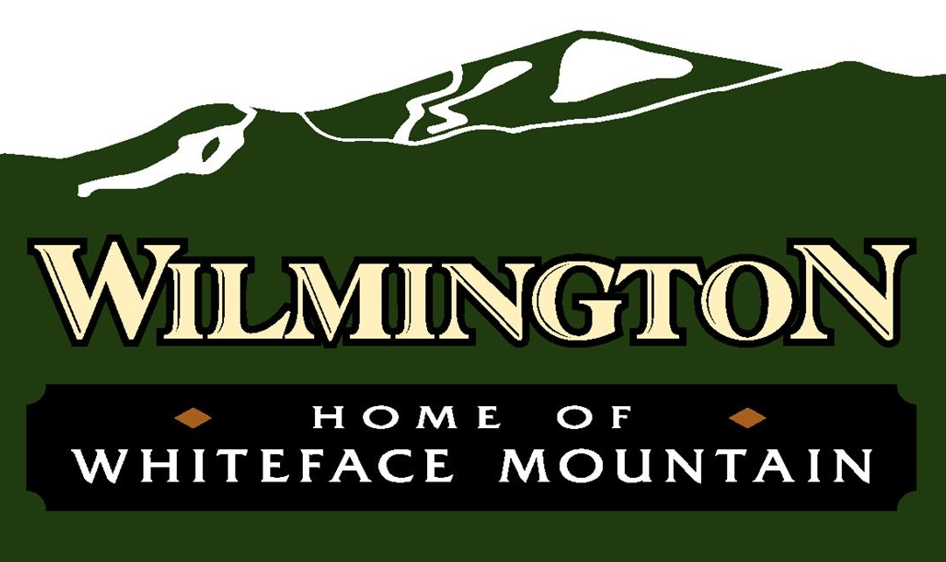

**AGENDA**

Community Center – February 26, 2025 – 4:00 pm

To join the virtual meeting please go to <https://meet.goto.com/townofwilmington>

Or join by phone by dialing

1-408-650-3123 Access Code: 377-399-733

1. Call to Order/Pledge of Allegiance
2. Discussions
   1. Guests—Adirondack Roots—Homesteading Housing/Coarding Property
   2. Guest--Doug Haney Ride to the River
3. Action Items—Ride to the River
4. Public Comment
5. Adjournment