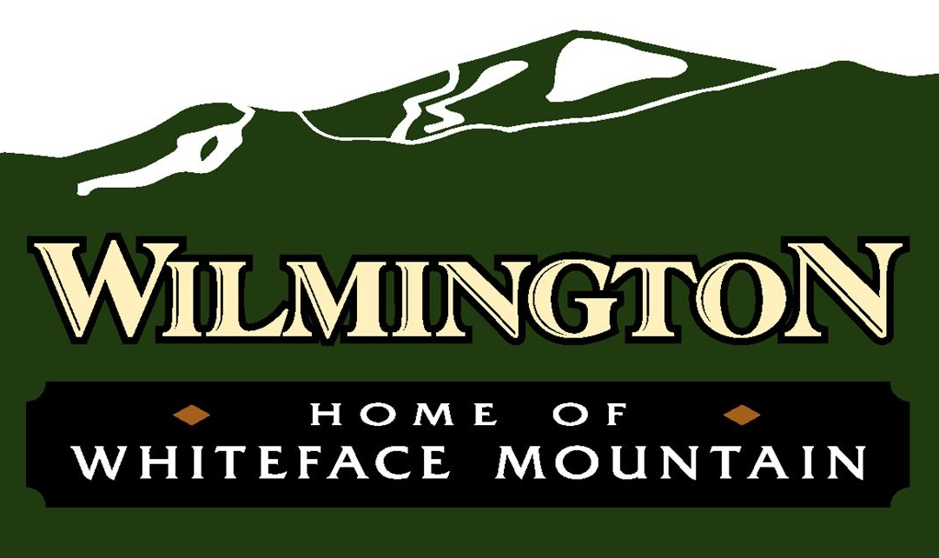

**AGENDA**

Community Center – March 11, 2025 – 6:00 pm

To join the virtual meeting please go to <https://meet.goto.com/townofwilmington>

Or join by phone by dialing

1-408-650-3123 Access Code: 377-399-733

1. Call to Order/Pledge of Allegiance
2. Approval of Minutes
   1. February 11, 2025 Regular Meeting
   2. February 25, 2025 Regular Work Session Meeting
3. Discussions/Guests—Dan Kelleher (ROOST)—Report and Update
4. Reports from Departments
   * 1. Highway ii. Water (Written) iii. Parks iv. Codes (Written) v. Dog Control (No Report)
5. Reports from Board Members
   * 1. Follos
     2. Forbes
     3. Hooker
     4. Preston
     5. Smith
6. New Business/Resolutions
   1. Purchase of dump trailer for Parks Department with funds coming from Community Enhancement
   2. Purchase of playground feature with already budgeted funds
   3. Request/Question—Food Vendor(s) at Beach for Summer Concerts
   4. Request for disconnect from municipal water
   5. Authorizing supervisor to execute the following agreements for 2025:
      1. With Essex County (Emergency Services) for the intercept car services
      2. With Essex County (Department of Elections) for use of community center; and
      3. With the Whiteface Visitor’s Bureau for promotional services.
7. Old Business
   1. Consideration of previously tabled/omitted resolutions: Fund Balance Policy, Reserve Funds Policy, Procurement Policy and Special Counsel engagement.
   2. Consideration of transfer station fees
8. Claims Audit/Budget Transfers
   * + 1. Bill Pay Resolution (February 14, 2025 to March 11, 2025).

1. Public Comment
2. Adjournment