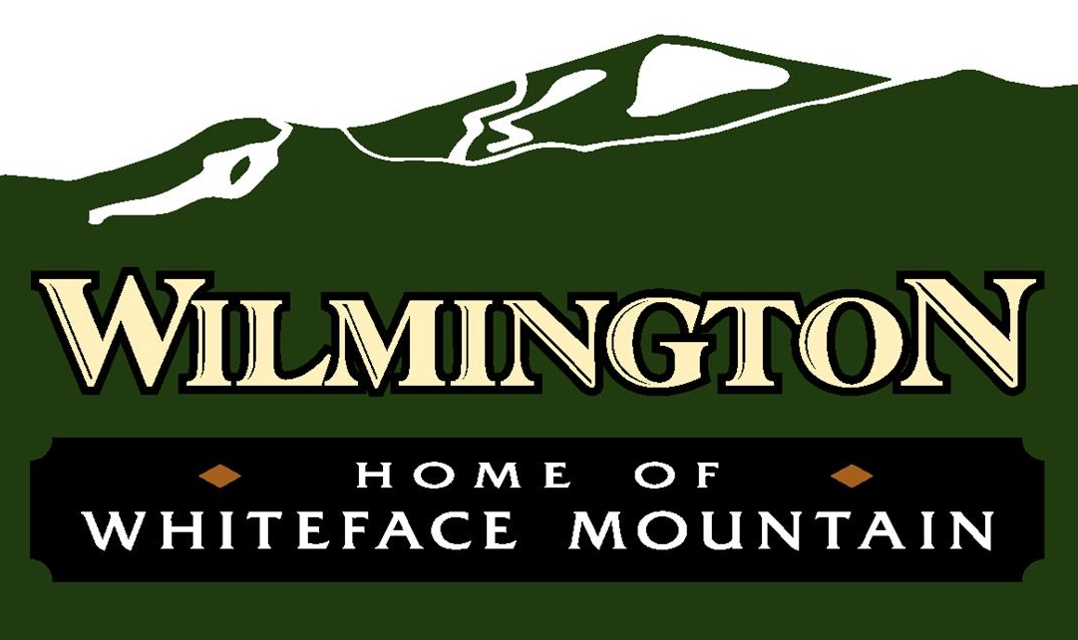

**REGULAR WORK SESSION AGENDA**

Community Center – July 30, 2025 – 4:00 pm

To join the virtual meeting please go to <https://meet.goto.com/townofwilmington>

Or join by phone by dialing

1-408-650-3123 Access Code: 377-399-733

1. Call to Order/Pledge of Allegiance
2. Old Business—Further Review, Discussion and/or Action on proposed changes to land use ordinance
3. Public Comment
4. Executive Session—discussions regarding proposed, pending or current litigation.
5. Adjournment