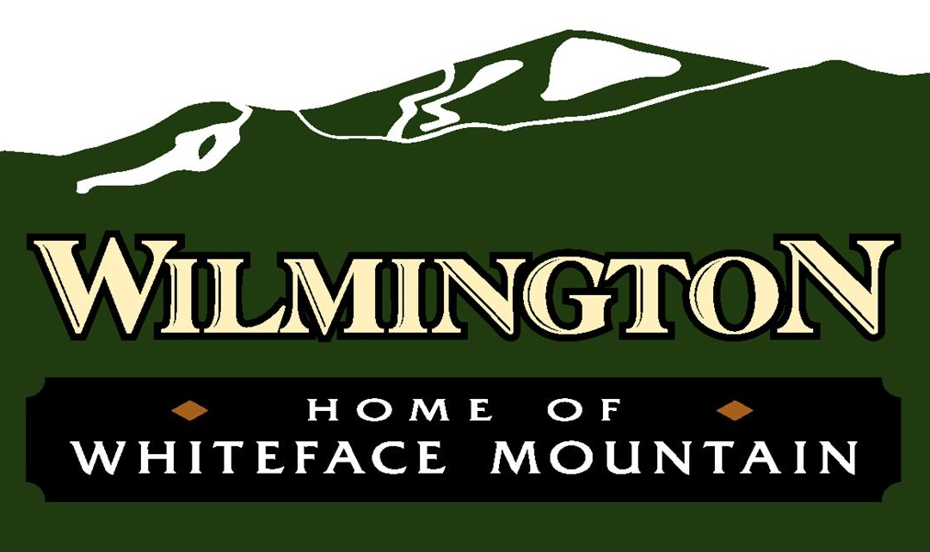

**AGENDA**

Community Center – August 12, 2025 – 6:00 pm

To join the virtual meeting please go to <https://meet.goto.com/townofwilmington>

Or join by phone by dialing

1-408-650-3123 Access Code: 377-399-733

1. Call to Order/Pledge of Allegiance
2. Approval of Minutes
3. Reports from Departments
   * 1. Highway ii. Water (Written) iii. Parks iv. Codes (Written) v. Dog Control (Supervisor)
4. Reports from Board Members
   * 1. Follos;
     2. Forbes;
     3. Hooker;
     4. Preston;
     5. Smith
5. New Business/Resolutions
   1. Permission for use of Hardy Road—Wilmington Bike Fest
   2. Discussion/Action on procedure for Hardship Review—STR Permit Cap
   3. Review of proposed zoning ordinance changes
6. Old Business
7. Claims Audit/Budget Transfers
   * + 1. Bill Pay Resolution (July 9, 2025 to August 11, 2025)

1. Public Comment
2. Executive Session—to discuss pending legal matters
3. Adjournment