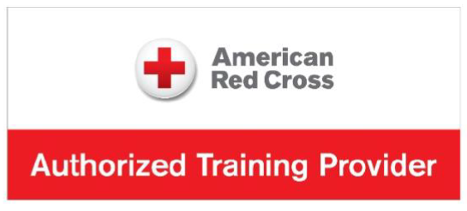

LIFEGUARD CPR FOR THE PROFESSIONAL RESCUER
RECERTIFICATION CLASS
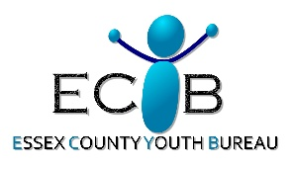
Date: May 24th 1:00-6:00PM
Sponsored by

Please plan accordingly and bring any drinks, snacks, food, etc.,
as scheduled breaks will be given throughout the session as needed.

COST:
$40.00
Location: Word of Life Bible Institute
4230 Glendale Rd
Pottersville, NY 12860
Health and Athletic Center

Class size is limited to 10 participants!
Don’t wait!! Call ASAP to reserve your spot!

Please call by Monday, May 11th 2026 to register:
Jeanine Melville - Phone (609) 501-1058

