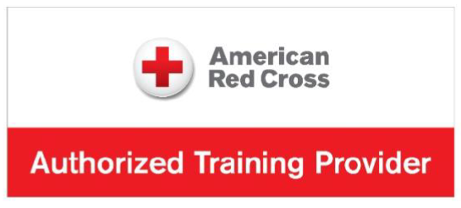

LIFEGUARD TRAINING OPPORTUNITY
RECERTIFICATION CLASS
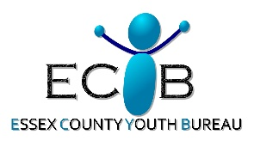
Sponsored by
Date: May 17th 9AM-9PM

This course will be taught in a BLENDED LEARNING FORMAT. Participants will need to complete
a fair amount of online course material prior to the start of the May 17th in-person class.
Proof of successful online completion is required in order to participate in the in-person sessions.

All classes must be attended and all requirements must be met in order to obtain certification.

Please plan accordingly for the long session and bring any drinks, snacks, food, etc.,
as scheduled breaks will be given throughout the sessions as needed.

COST:
$75.00
Location: Moriah Central School
39 Viking Lane, Port Henry, NY 12974

Class size is limited to 10 participants!
Don’t wait!! Call ASAP to reserve your spot!

Please call by Friday, April 24th 2026 to register:
Jeanine Melville - Phone (609) 501-1058

